IMAT3451 Final Year Project Periodic Progress Report (PPR)

Programme/Course Title: Computer games programming

Name: connor Rowland Assessment Period: week 4

Project Title: Dobble Report Number: 2

Objectives for Period: (refer to previous report)
Complete project contract, BCS checklist, Ethics Review Form, Global Checklist and version 1 of project backlog.

Summary of Progress for Period: (identify evidence of progress)

All completed.

Problem Areas and Suggested Solutions:

Additional detail needed in the project backlog.

Objectives, Deliverables & Plan for Next Period:

Improve backlog.
First draft of lit review: 2D packing algorithms and Networking.

Date of Next Review: 10:30 02/11/2018

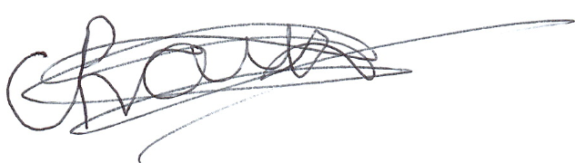

Student’s Signature: Date: 24/10/2018
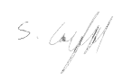

Supervisor’s Signature: Date: 24/10/2018

Comments (if any):

